Emotional Based Audio Playback and Stress Monitoring System for Autism

A. Kanchana1,Sreenidhyee E2, Srinitheka T3, Suvetha J4

Assistant Professor1, UG Scholar2,3,4

Department Of Computer Science And Engineering

Panimalar Engineering College

[akanchana2683@gmail.com 1](mailto:akanchana2683@gmail.com%201), [sreenidhyee@gmail.com](mailto:sreenidhyee@gmail.com) 2, [srinitheka@gmail.com 3](mailto:srinitheka@gmail.com%203) , [jsuvetha1@gmail.com](mailto:jsuvetha1@gmail.com) 4

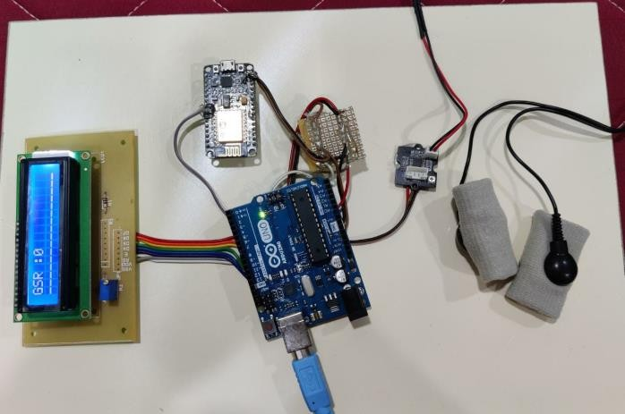

***Abstract- Nowadays Autism children find it difficult to interact socially with people's emotions and make themselves isolated. This project proposes Emotion detection for Autism spectrum disorder children (ASD). It is self-possessed of python libraries Open CV, Haar-cascade method to predict face. And for better involvement in the children’s social behavior, here a face is captured in real-time, and emotions are predicted by Facial expression recognition (FER). This proposed system helps to improve Autism children’s behavior by observing their facial expressions, and audio feedback. The main objective of this system is to capture an image in real-time and then recognize whether it is a human face using the Computer Vision technique. If the Predicted facial Emotion is sad, then we will play some Interesting Audio to them using AT mega Microcontroller, which will keep them relaxed and will help them to learn interactively. Along With that we have designed and built a stress sensor based on Galvanic Skin Response (GSR), to find their stress level and monitor it over the Internet Using Node MCU.***

***Keywords: Autism spectrum disorder (ASD), OpenCV, Learning, Facial expression recognition (FER), Galvanic Skin Response (GSR), Stress Detection.***

# INTRODUCTION

Autism spectrum disease affects the nervous system and impacts the overall cognitive, emotional, social, and bodily health. The common signs and symptoms encompass issues with verbal exchange, trouble with social interactions, obsessive hobbies, and repetitive behaviors. Early recognition, in addition to behavioral, educational, and family therapies - may lessen signs and symptoms and help in development and learning. Recently, a few computer-mediated systems have been designed for caregiver-child interaction, but not in the context of ASD intervention

The primary goal of this system is to capture an image in real-time and recognize whether it is a human face by using the Computer Vision technique. After detecting the human faces from live input, and examining the facial expressions using a Deep Neural Network and If the Predicted facial Emotion is happy, then we will play some Interesting Audio to them using AT mega Microcontroller, which will keep them relaxed and will help them to learn. Face recognition comes under the domain of Computer Vision which is an approach to identifying and recognizing images. Currently, they are being applied to various applications to solve real-world problems in many fields such as industries, manufacturing, healthcare, etc., for public security, marketing, banking, etc. Social media platforms have advanced algorithms capable to perform various functionalities in facial recognition to attract a wider user base.

Fig 1 Hardware components

# LITERATURE SURVEY

Guangtao Nie Et al [11] An immersive Computer-mediated Caregiver-Child Interaction (C3I) system to assist kids with ASD applies IJA skills. C3I could be a novel computerized intervention system that integrates a caregiver within the teaching loop, thereby protecting the benefits of each human and computer- administered intervention. A practicability study with vi dyads (caregiver-child with ASD) was conducted. A close to important increase with medium impact size on IJA performance was ascertained. Meanwhile, physiology-based stress analysis showed that C3I didn't increase the strain on the caregivers throughout the study. To the most effective of our information, this is often the primary autonomous system designed for teaching IJA skills to kids with ASD incorporating caregivers within the loop to reinforce the potential for generalization within the real world.

V.Y Tittagalla Et al [14] A person with syndrome Spectrum Disorder (ASD) typically has problem with social and communication skills. within the past few years, there hasn’t been a correct means of distinctive unfit youngsters in land. during this analysis paper, we are going to discuss a way to establish Associate in Nursing unfit kid by considering a mobile applications on with the subsequent factors. establish the attention contact, responsiveness to stimulant, analysis of vocal behavioural patterns, and form. The on top of four factors are going to be the most key areas within the screening method. This tool is formed particularly for distinctive youngsters with syndrome in rural areas in land. the key 3 areas of eye contact, vocal behavior, and responsiveness area unit the screening method is developed for proof of conception during this analysis.

# Alanoud Bin Dris Et al [13] Accordingly, in our analysis, we have a tendency to square measure getting to speed up diagnoses by combining gaze- based screening with intelligent strategies like machine learning which might act as a transformative step for distinguishing ASD at its early stages. during this analysis, we have a tendency to used Support Vector Machine (SVM) algorithmic program to look at the performance in terms of 4 completely different measures that square measure accuracy, sensitivity, specificity and space underneath the curve (AUC). Results discovered that SVM accomplished high classification performance once applied on our collected eye movement information set.

# Geraldine Dawson Et al [12] Research on syndrome spectrum disorder (ASD) suggests that behavioral risk markers is discovered at twelve months more mature or earlier, with diagnosing potential at eighteen months. To date, these studies and evaluations involving empiric analysis tend to bank heavily on clinical practitioners and specialists United Nations agencies have undergone intensive coaching to be ready to dependably administer rigorously designed behavioral-eliciting tasks, code the ensuing behaviors, and interpret such behaviors These ways area unit thus extraordinarily high-ticket, time-intensive, and aren't simply ascendable for giant population or longitudinal empiric analysis. we have a tendency to developed a self-contained, closed-loop, mobile application with moving-picture show stimuli designed to interact the child’s attention and elicit specific behavioural and social responses, that area unit recorded with a mobile device camera so analyzed via laptop vision algorithms. The results recommend these objective and automatic ways is thought of to help behavioural analysis, and may be fitted to objective automatic analysis for future studies.

# Sarah Afiqh Mohd Zabidi Et al [22] This paper focuses on the event of an easy bit device primarily based game to unproved psychological feature talent in ASD kids psychological feature skills embrace thinking, learning and resolution issues. the sport designed during this system can facilitate the kid to be told colours and shapes through sorting and classifyıng the blocks. though naming colours and classifying shapes is wont to most adults, it's truly a cognitively complicated task for young kids. the aim of this study is to create Associate in Nursing helpful device which will be a good learning medium for ASD kid and may be utilized by therapists throughout the session. This device will log knowledge in period of time which might facilitate reduce the therapist's work and facilitate them specialise in the kid throughout medical aid.

# Lian Zhang Et al [15] Autism Spectrum Disorder (ASD) could be a neurodevelopmental disorder characterized by core deficits in social interaction and communication. cooperative puzzle games as interactive activities that may be contended to foster the collaboration and verbal-communication skills of kids with ASD. during this paper, we've designed AN intelligent agent that may play cooperative puzzle games with youngsters and verbally communicate with them as if it's another human player. moreover, this intelligent agent is additionally able to mechanically live youngsters task-performance and verbal- communication behaviors throughout gameplay 2 preliminary studies were conducted with children with ASD to gauge the practicability and performance of the intelligent agent. Results of Study I incontestable the intelligent agent’s ability to play games and communicate with youngsters inside the game-playing domain. Results of Study II indicated its potential to live the communication and collaboration skills of human users.

# Zeyad Abdulhameed Et al [16] The current paper could be a review of eye-tracking and sensing technologies that observe and monitor syndrome Spectrum Disorder (ASD). Nowadays, the most important challenge is that the detection of syndrome before the age of thirty six months. The identification of syndrome within the early stage of life will facilitate unfit youngsters improve their social communication and quality of life. Therefore, the technology will support psychologists to urge the correct diagnoses of syndrome and consequently the unfit youngsters will get acceptable treatment for his or her condition. during this review, the main focus is on eye - chase and sensing technologies. The unfit youngsters have totally different basic cognitive process biases in social interactions that may be measured by eye-tracking technology. Moreover, unfit youngsters have some signs that may be simply detected by victimisation sensing technology like hand flap, body rocking and, motion trackers.

# Shirajul Islam Et al [17] Our study aims to estimate ASD (autism spectrum disorder) at a sooner doable time and increase accuracy than the previous analysis and cut back medical prices. In our thesis paper, we would like to predict and distinguish between unfit and non- autistic youngsters by employing a machine learning approach. Firstly, we've gathered knowledge from the police investigation aspect the maximum amount is doable. we have a tendency to additionally set some specific queries and check out to search out the most correct answers to all or any queries. moreover, supervised learning algorithms are applied to diagnose whether or not youngsters meet the symptoms of ASD. Among all applied algorithms KNN and Random Forest shows the most accuracy and speed the identification. Above all, our final goal is to make a web tool that may offer machine learning-based Associate in Nursing analysis to a user to find syndrome at an early age exactly.

# Uzma Hasan Et al [18] With the advancement of technology, a large vary of automatic tools are currently accustomed teach youngsters with the syndrome. one of the wide used therapies for kids with syndrome Spectrum Disorder (ASD) is Applied Behaviour Analysis (ABA) coaching which focuses on up a large vary of behaviors like communication, adaptive learning skills, social skills, and a spread of motor skills. Thus, the target of this text is to style and develop a recreation application for unfit youngsters for up their psychological feature skills. the web of Things (IoT) and ABA Techniques were adopted to develop the recreation application that consists of here recreation a puzzle game, AN object finding game, and a road crossing game. The psychological feature development (in terms of recreation scores) of a baby over time will be keep and analyzed exploitation this application. A light-weighted analysis study was carried out; and located that the projected recreation application is usable, effective and helpful for unfit youngsters to enhance their psychological feature skills.

# Joao F. Santos Et al [19] Very early detection has become a key priority analysis topic, as early interventions will increase the probabilities of success. Since atypical communication may be a hallmark of ASD, automatic acoustic-prosodic analyses have received distinguished attention. Existing studies, however, have targeted on verbal kids, generally over the age of 3 (when several kids could also be dependably diagnosed) and as high as early teens. Here, AN acoustic-prosodic analysis of pre- verbal vocalizations (e.g., babbles, cries) of 18-month recent small fry is performed. knowledge was obtained from a prospective longitudinal study staring at bad siblings of youngsters with ASD United Nations agency were additionally diagnosed with ASD, additionally as low-risk age-matched generally developing controls. many acoustic-prosodic options were extracted and wont to train support vector machine and probabilistic neural network classifiers; classification accuracy as high as ninety seven was obtained. Our findings counsel that markers of syndrome could also be gift in pre-verbal vocalizations of 18-month recent toddlers, so could also be wont to assist

# EXISTING SYSTEM

As with any student, children with ASD profit most once lecturers and parents are on the same page and constant efforts at home and college. Before designing a lesson, the teacher ought to initially meet with folks to debate the likelihood of a category lesson concerning syndrome. It's vital to urge parent input, and if acceptable, input from the scholar with syndrome still. Since many teachers must be appointed for many children. In this way online class for autistic kids is difficult. Since parents and teachers must closely monitor the child’s reaction. It’s a tedious process for parents as well as teachers. Teachers are requested to conduct one-on-one classes in this scenario to ensure that child concentrates in class and grasp concepts. The main disadvantage of this method is teachers must watch out for only one kid at a time and typically this method isn't effective.

# PROPOSED SYSTEM

# 

# Fig 2 Block Diagram

The main objective of this system is to capture an image in real-time and then recognize whether it is a human face using the Computer Vision technique. After detecting the human faces from an image, and observe the facial expressions using Deep Neural Network and If the Predicted facial Emotion is happy, then we will play some Interesting Audio to them using AT mega Microcontroller, which will keep them relax and will help them to learn. Along With that we have designed and built a stress detector using Galvanic Skin Response (GSR). For this objective, we have to calculate the different conductance of the skin when a person is under stress or when not using Galvanic Skin Response (GSR) device. For this objective, we have to calculate the different conductance of the skin when a person is under stress and when not under stress using Galvanic Skin Response (GSR) device. We compare the output of face detected emotion and also sweat conductance level. The average of this is considered as the actual emotion of the child and audio is played based on that. The data is stored in a cloud (ThingSpeak) application with a unique Channel ID which is managed by the Admin. Using this ID parents and therapists can access the details of the child which will be helpful to evaluate and study their mood swings and attention span. The GSR value along with time, date, and entry number can be exported from ThingSpeak application. Parents can also login to their mobile application and monitor their childs emotion in the form of graph. Values gets updated every second without any delay.

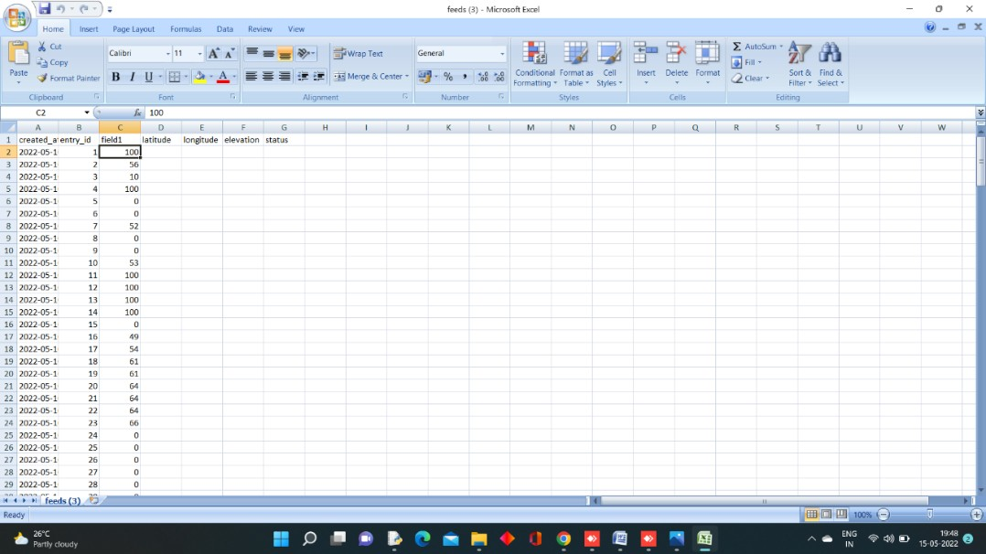

Fig ThingSpeak application-Exported data

which gets downloaded in .csv form

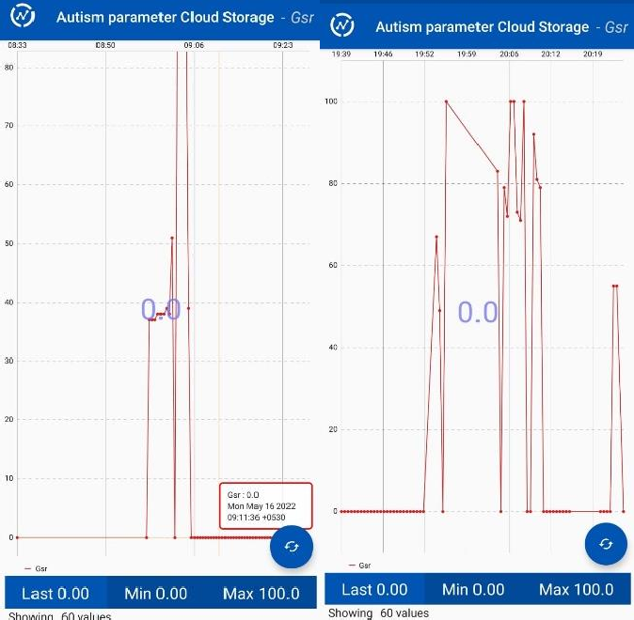

Fig 7.5 ThingSpeak application from Parents or Therapist side

# SYSTEM ARCHITECTURE

# Architecture diagram.png

Fig 4.1: System Architecture

This Project is divided into two sectors one is the software part and another is the Hardware Part. The Project will be Using a Convolution Neural network Algorithm to detect the Facial Emotion and by using the Trained Model we will be identifying the Emotion by comparing the Image of the Live Input with the Model file and then based on the Emotion we will Train them by playing Rhymes when their Emotion is Happy and we are also using Hardware part as Mental Health is very Important to everyone we will be using Galvanic Skin Response Sensor where Electrodes is Connected to the Subject and Based on the Threshold Values we will storing the Data in the Cloud Platform which becomes very useful for the Parents or Care taker to analyse their Mental Space as well. The reason of Focusing both these aspects are they might have possible anxiety with mingled with crowd, and By Analysing the Facial Emotion we can also help them learn things, we believe technology should reach all medium of users and will help them overcome their problems.

# VI. OUR METHODOLOGY

# EXPLORING THE DATASET

From Kaggle open resource, we had a training dataset, a public test dataset (which is then used as a validation dataset for our project), and further a private test dataset (same size as the public test dataset and will be used as data for evaluating the prediction performance). Image set of 35,887 examples, with training-set : 80% validation-set : 10% test-set : 10%.

In this we are performing three processes they are:

* 1. Initiate CV
  2. Resizing
  3. Comparison
  4. Audio Feedback
  5. Data storage on Cloud

# HAAR CASCADE

A sequence of rescaled “square-shaped” functions along with kind of a moving ridge family or basis. it's supported the Haar moving ridge technique to analyze pixels within the image into squares by operation. This uses machine learning techniques to urge a high degree of accuracy from what's known as “training data”. This uses “integral image” ideas to cipher the “features” detected. Haar Cascades uses the Adaboost learning algorithmic program that selects a tiny low range of necessary options from an oversized set to relinquish Associate in Nursing economical results of classifiers.

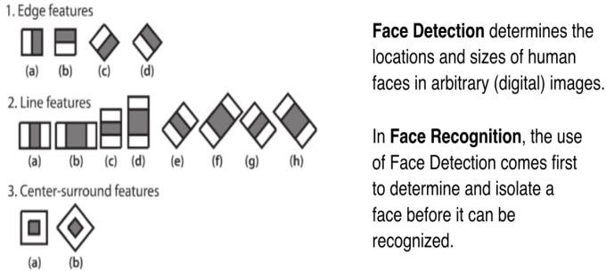

Fig 3.1 Haar Cascade

This is a quick illustration of options Extraction and therefore the distinction between Face Detection and Face Recognition. Face detection is regarding locating, whereas face recognition is regarding distinguishing.

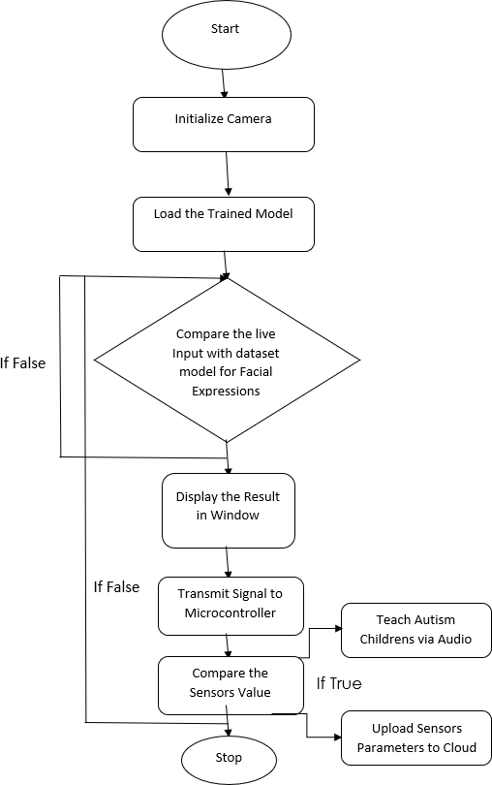

Fig 3.2 Working flow of Emotion prediction system

# FEATURE EXTRACTION

Haar Cascades uses machine learning techniques in which a function is trained from a lot of positive and negative images. This process in the algorithm is feature extraction. In feature extraction, the algorithm uses training data to best identify features that it can consider a face. The training data used in this project is an XML file called: haarcascade_frontalface_default.xml

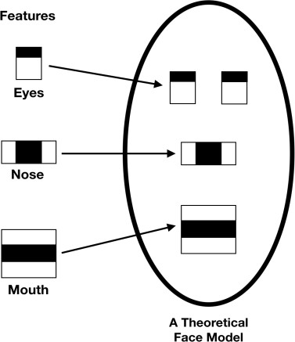

Fig 3.3 Feature Extraction

# RUNNING OPENCV

For this project we prepared a directory where I dumped all the files needed. You will need to put in this directory the following:

1. face_detection.py (the name I gave to the Python program that contains code. This name can be changed.)
2. haarcascade_frontalface_default.xml (Haar Cascade training data)
3. photos
4. **STEPS**

The main concept used to predict the Emotion of Autism children’s and Play Music’s based on their Emotions. The flow of the project is as follows:

1. First using read the image from the Camera by using OpenCV
2. Then, the haar cascade method is used to detect faces in each frame of the webcam feed.
3. The region of the image containing the face is resized to 48x48 and is passed as input to the CNN.
4. The feeling with the maximum score is displayed on the screen.

Based on the Emotion Audio Will be played.

# CONVENTIONAL NEURAL NETWORKS

CNNs are a class of Deep Neural Networks that can recognize and classify particular features from pictures and are widely used for analysing visual images. There are used widely in medical image analysis. The term ‘Convolution” in CNN denotes that two images can be represented as matrices which are multiplied to give an output that is used to extract features from the image.

# IMAGE CLASSIFICATION BASED ON CNN

Image Classification is the process of finding instances of real- world objects such as faces, buildings, and bicycles in images or videos. Image classification algorithms typically use extracted features and learning algorithms to recognize instances of an object category. It is commonly used in applications such as image retrieval, security, and advanced driver assistance systems.

Classification of images is an important topic in artificial vision systems and had drawn a significant amount of interest over the last decades. After that, feature detection methods inbuilt on this pre-defined model for the training and testing of our project. By using those feature extraction methods some parameters values of features are calculated. However, when a lot of images were given, it was a too difficult problem to find features from them. This was one of the reasons that a deep neural network model is used. To extract the features from Alex net that are trained on bone dataset. CNN uses over each image and adjusts the kernel as per the propagation in the network. A kernel was then convolved over the entire image to produce feature maps. As the layers become deeper, the network acquires the knowledge of larger feature extraction. The initial layers take care of the smaller details of the image and the deeper layer can identify the more number details from the image. It was pre-processing the images and extracting the features by feed-forwarding through the network, and also specifying the layer names that can be extracted and save them.

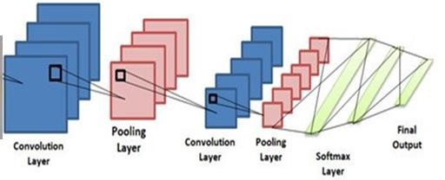

Fig 3.4: CNN Classification

# SOFT MAX FUNCTION

The soft max function is used as the activation function in the output layer of neural network models that predict a multinomial probability distribution. That is, soft max is used as the activation function for multi-class classification problems where class membership is required on more than two class labels. The final output is calculated using soft max which gives the probability of each class for given features.

# TRAINING AND TESTING THE NETWORKS

1. Weight Initialization.
2. Learning Rate.
3. Activation Functions.
4. Network Topology.
5. Batches and Epochs.
6. Regularization.
7. Optimization and Loss.
8. Early Stopping.

The dataset contains a test folder and in a test.csv file, the details related to the image path and the irrespective class labels are specified. The image path and labels are extracted using pandas. Then to predict the model, the images are resized to30×30 pixels and a numpy array containing all image data is made. From the skin learn. metrics, the confusion matrix is imported and observed how the model predicted the actual labels. A result, 95% accuracy of the model is achieved.

The sample data is used to fit the model the actual dataset that was used to train the model(weights and biases in the case of CNN). The model sees and learns from this data.

# VII. TECHNOLOGY STACK

# HARDWARE REQUIREMENTS

# NODEMCU v2

The NodeMcu is an open-source firmware and development kit that helps you to Prototype your IOT product within a few Lua script lines. Features of this include Open-source, interactive, Programmable, Low cost, Simple, Smart, WI-FI enabled.

**ARDUINO MEGA**

Arduino is a single-board microcontroller to makes victimization physics in multidisciplinary projects more accessible. The hardware consists of a simple open source hardware board designed around an 8-bit Atmel AVR microcontroller or a 32-bit Atmel ARM. The code consists of a typical programming language compiler and a boot loader that executes on the microcontroller.

# LCD DISPLAY

The term LCD stands for liquid crystal display. It is one kind of electronic display module used in an extensive range of applications like various circuits & devices like mobile phones, calculators, computers, TV sets, etc. These displays are mainly preferred for multi-segment light-emitting diodes and seven segments. The main benefits of using this module are inexpensive; simply programmable, animations, and there are no limitations for displaying custom characters, special and even animations, etc.

# GSR SENSOR

GSR stands for galvanic skin response and it's a way of measuring the electrical phenomenon of the skin. Robust emotions will cause input to your sympathetic systema nervosum, ensuing in additional sweat being secreted by the sweat glands. Grove ‐ electrodermal response permits you to identify such robust emotions by merely attaching 2 electrodes to 2 fingers on one hand. It's a stimulating gear to make feeling connected comes like a sleep quality monitor.

# FRONT END-PYTHON 3.8

1. OpenCV
2. NumPy
3. Keras

# OpenCV

OpenCV-Python is a library of Python bindings designed to solve computer vision problems. It makes use of Numpy, which is a highly optimized library for numerical operations with MATLAB-style syntax. All the OpenCV array structures are converted to and from Numpy arrays. It is nothing but a wrapper class for the original C++ library to be used with Python. Using this, all of the OpenCV array structures get converted to/from NumPy arrays. This makes it easier to integrate it with other libraries which use NumPy. For example, libraries such as SciPy and Matplotlib.

It is an open-source computer vision and machine learning software library. It was built to provide a common infrastructure for computer vision applications and to accelerate the use of machine perception in the commercial products.

# NumPy

NumPy is, just like SciPy, Scikit-Learn, Pandas, etc. one of the packages which cannot be missed while learning data science, mainly because this library provides an array data structure that holds some benefits over Python lists, such as: being more compact, faster access in reading and writing items, being more convenient and more efficient. To make a numpy array, np.array() function is used.

# Keras

Keras is an open-source neural-network library written in Python. It is capable of running on top of Tensor Flow, Microsoft Cognitive Toolkit, R, The a no, or Plaid ML. Designed to enable fast experimentation with deep neural networks, it focuses on being user-friendly, modular, and extensible.

# BACKEND-TENSORFLOW2.0

Tensor Flow is an end-to-end open-source platform for deep learning. It has a comprehensive, flexible ecosystem of tools, libraries, and community resources that lets researchers push the state-of-the-art in deep learning and developers easily build and deploy deep learning-powered applications. It is a general- purpose high-performance computing library open-sourced by Googlein2015. From the beginning, its main focus was to provide high-performance APIs for building Neural Networks (NNs). However, with the advance of time and interest by the Deep learning community, the lib has grown to a full deep learning ecosystem.

# RESULT AND DISCUSSION

The Performance of Haar cascade, CNN and GSR Sensor was estimated with classification performance of the Average Received values, Neutral, Happy and Sad. The Performance of having Two Powerful Technologies Machine Learning and Embedded Systems integrated with Internet of Thing platform helps in Providing Rapid Solution to Kids with Autism by playing their Rhymes based on the values received from both GSR Sensor and the Facial Emotion values. In this Experiment we found that using GSR Sensor and Facial Emotion Comparison for Audio Based Feedback for Kids are Compared, Matched and the data are stored correctly and we are getting 95% accuracy on the tested data.

**IX SCREENSHOTS**

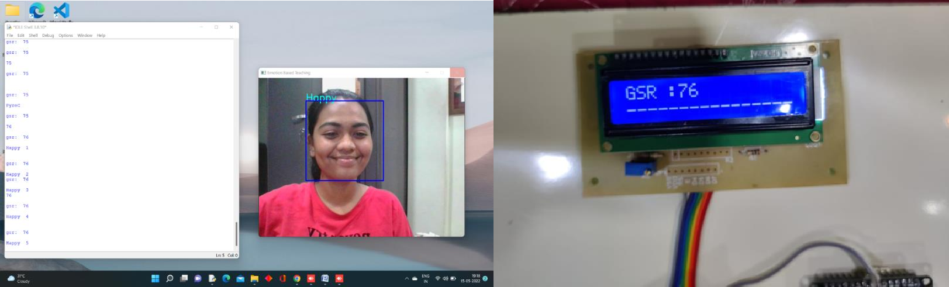

Fig 7.1. Screen when Happy Is detected along with GSR value on LCD

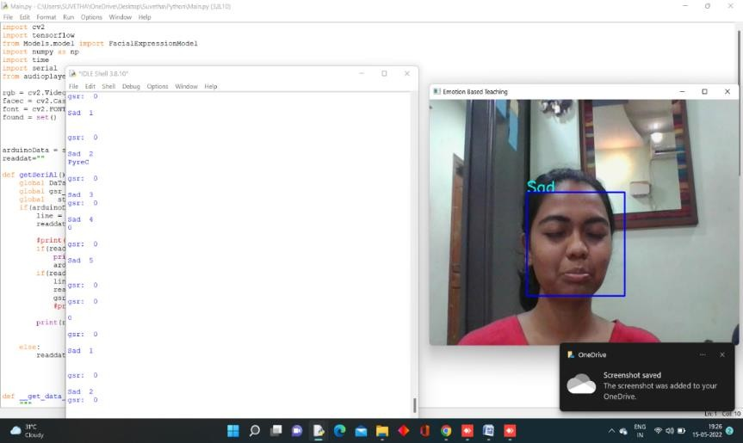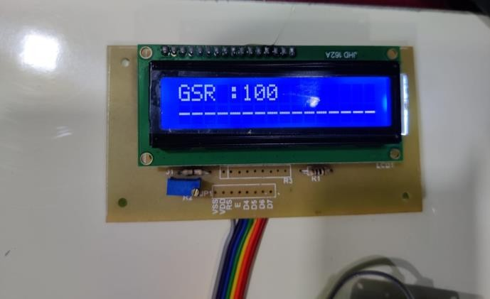

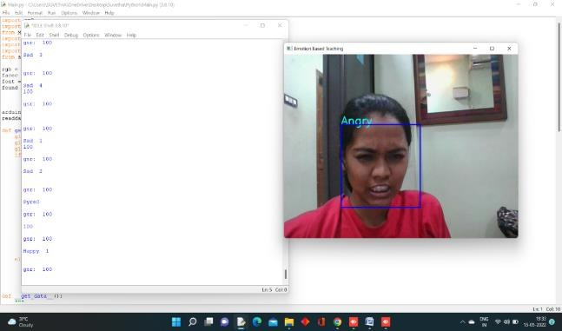 Fig 7.2. Screen when Sad/Anxious is detected along with GSR value on LCD

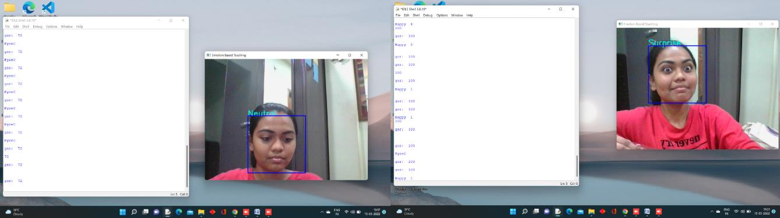

7.3. Screen when Neutral, Surprised, Angry is detected

# X. CONCLUSION

Thus a completely unique methodology to monitor autistic children and find stress levels has been projected and the results are shown as screenshots. The method proposed above uses transform methods and horizontal projection profiles each of that has economical and fast hardware implementation, to not only monitor autistic children but additionally play audio based on their reactions. The audio played is not only based on their facial reaction it compares the GSR value also (sweat conductance).

The GSR values are stored in the ThingsView application(cloud). Which can be seen by parents and therapists in the form of a graph. It can be downloaded in the form of Excel sheet (.csv) which will be used to detect the mood swings of the child. This system helps to provide non-invasive rehabilitation therapy for children with autism.

**XI. FUTURE WORK**

In the proposed System we have Tested Facial Expression using Convolution Neural Network Prediction and comparing the output with a Galvanic Skin Response sensor to analyze the Emotion level of the Kid with ASD (autism spectrum disorder) we were able to predict the Facial Emotion, and compare the values Successfully and providing the system the higher success rate. In the future, we can combine Pulse Rate Sensor and Restless Detection along with a Non-Invasive Therapy system which will help us to analyze in-depth data and by providing them with a non-invasive rehabilitation therapy for Immediate Relief.

# XII. REFERENCES

# Y. M. Al-Farsi, M. M. Al-Sharbati, O. A. Al-Farsi, M.S. Al-Shafaee, D. R. Brooks, and M. I. Waly, “Brief Report: Prevalence of Autistic Spectrum Disorders in the Sultanate of Oman,” Journal of Autism and developmental Disorders, vol. 41, no. 6, pp. 821–825, Jun.2011.

1. V. Eapen, A. A. Mabrouk, T. Zoubeidi, and F. Yunis, “Prevalence of Pervasive Developmental Disorders in preschool Children in the UAE,” Journal of Tropical Pediatrics, vol. 53, no. 3, pp. 202–205, Jan.2007.
2. M. AL-zaalah, A. AL-asmari, H. AL-malki, N.AL-shehri,N.AL-moalwi, and O. Mostafa, “Characteristics of Autism Spectrum Disorder among Saudi Children and its Impact on their Families,” MEDICAL JOURNAL CAIRO UNIVERSITY, vol. 83,no. 2, pp. 239–244, 2015.
3. F. M. Alnemary, F. M. Alnemary, and Y. A. Alamri,“Autism Research: Where Does the Arab WorldStand?,” Review Journal of Autism and Developmental Disorders, vol. 4, no. 2, pp. 157–164,Jun.2017.
4. E. DiCicco-Bloom et al., “The Developmental Neurobiology of Autism Spectrum Disorder,” Journal of Neuroscience, vol. 26, no. 26, pp. 6897–6906, Jun.2006.
5. D. P. Wall, J. Kosmicki, T. F. DeLuca, E. Harstad, and V.A. Fusaro, “Use of machine learning to shorten observation- based screening and diagnosis of autism,” Translational Psychiatry, vol. 2, no. 4, pp. e100–e100, Apr. 2012.

# Brett Baisch, Sean Cai, Zongming Li, Victor Pinheiro, “Reaction Time of Children With and Without Autistic Spectrum Disorders”,03-Jun-2017.

1. W. Liu, M. Li, and L. Yi, “Identifying children with autism spectrum disorder based on their face processing abnormality: A machine learning framework: Face Processing in Autism,” Autism Research, vol. 9, no. 8, pp. 888–898, Aug.2016.
2. H. Zhao, A. R. Swanson, A. S. Weitlauf, Z. E. Warren,and N. Sarkar, “Hand-in-hand: A communication-enhancement collaborative virtual reality system for promoting social interaction in children with autism spectrum disorders,” IEEE Trans.Human-MachineSystem.,vol.48,no.2,pp.136–148,Apr. 2018.
3. Z. Zheng, G. Nie, A. Swanson, A. Weitlauf, Z. Warren, and N. Sarkar, “A randomized controlled trial of an intelligent robotic response to joint attention intervention system,” J. Autism Develop. Disorders, vol. 50, pp. 1–13, Feb.2020.

# Guangtao Nie and Akshith Ullal , Zhi Zheng , Amy R. Swanson , Nilanjan Sarkar, “An Immersive Computer- Mediated Caregiver-Child Interaction System for Young Children With Autism Spectrum Disorder” IEEE, 978-1-7281- 4245-6, VOL 29, 2021.

# Geraldine Dawsfon, Kimberly L. H. Carpenter, Kathleen Campbell, Qiang Qiu, Steven Espinosa, Samuel Marsan, Jeffrey P. Baker, Helen L. Egger, “Computer Vision Analysis for Quantification of Autism Risk Behaviors, IEEE,Aug2018

1. Alanoud Bin Dris, Abdulmalik Alsalman, Areej Al-Wabil, Mohammed Aldosari, “Intelligent gaze-based screening system for autism”, IEEE, 978-1-7281-0108, 2019
2. V. Y Tittagalla, R. R. P Wickramarachchi, G. W. C. N. Chandrarathne, N. M. D. M. B. Nanayakkara, P. Samarasinghe, P. Rathnayake and M.G.N.M. Pemadasa. “Screening Tool for Autistic Children”, IEEE, 978-5386-7512-0, 2019
3. Lian Zhang, Ashwaq Z. Amat, Huan Zhao, Amy Swanson, Amy Weitlauf, Zachary Warren, “Design of an Intelligent Agent to Measure Collaboration and Verbal-Communication Skills of Children with Autism Spectrum Disorder in Collaborative Puzzle Games”
4. Zeyad Abdulhameed Taha Ahmed , Dr. Mukti E. Jadhav, “A Review of Early Detection of Autism Based on Eye- Tracking and Sensing Technology”, IEEE, ISBN:978-1-7281- 4685-0, 2020
5. Shirajul Islam, Tahmina Akter, Sarah Zakir, Shareea Sabreen, Muhammad Hossain, “Autism Spectrum Disorder Detection in Toddlers for Early Diagnosis Using Machine Learning”, IEEE, 978-1-6654-1974-1, 2020
6. Uzma Hasan , Md. Fourkanul Islam , Muhammad Nazrul Islam , Sifat Bin Zaman , Shaila Tajmim Anuva, Farhana Islam Emu, and Tarannum Zaki, “Towards Developing an IoT Based Gaming Application for Improving Cognitive Skills of Autistic Kids”, IEEE, 411-423, 2020.
7. Joao F. Santos, Nirit Brosh , Tiago H. Falk1 , Lonnie Zwaigenbaum, Susan E. Bryso , Wendy Roberts , Isabel M. Smith , Peter Szatmari and Jessica A. Brian, “Very Early Detection Of Autism Spectrum Disorder Based On Acoustic Analysis Of Pre-Verbal Vocalization Of 18-Month Old Toddlers”, IEEE, 978-1-4799-0356-6, 2013
8. P. Mundy, “Joint attention and social-emotional approach behavior in children with autism,” Develop. Psychopathol., vol. 7, no. 1, pp. 63–82, 1995
9. L. Billeci et al., “Disentangling the initiation from the response in joint attention: An eye-tracking study in toddlers with autism spectrum disorders,” Transl. Psychiatry, vol. 6, no. 5, p. e808, May 2016
10. Sarah Afiqh Mohd Zabidi, Hazlina Md Yusof, Sukreen Hana Herman, Shahrul Naim Sidek, “Simple Touch Sensor- based Game as Ambient Assistive Device for Mild Autism Spectrum Disorder Children”, IEEE, 978-1-7281-4245-6-6-21, 2021